

### T1650**(E)**(A13)T

**NATIONAL CERTIFICATE**

**STRENGTH OF MATERIALS AND STRUCTURES N5**

(8060065)

**13 April 2018 (X-Paper)**

**09:00-12:00**

#### REQUIREMENTS: Hot-rolled structural steel sections (BOE8/2)

**Calculators may be used.**

**This question paper consists of 6 pages and a formula sheet of 2 pages.**

#### DEPARTMENT OF HIGHER EDUCATION AND TRAINING

**REPUBLIC OF SOUTH AFRICA**

NATIONAL CERTIFICATE

STRENGTH OF MATERIALS AND STRUCTURES N5

TIME: 3 HOURS

MARKS: 100

##### INSTRUCTIONS AND INFORMATION

1. Answer ALL the questions.

1. Read ALL the questions carefully.

1. Number the answers according to the numbering system used in this question paper.

1. Write neatly and legibly.

##### QUESTION 1

A tensile test is carried out on a steel rod. The test piece has a diameter of 20 mm and is gauged to a length of 85 mm.

The following results were obtained during the test:

* Load at the limit of proportionality: 72 kN

* Change in length at the limit of proportionality: 110 μm

* Load at yield point: 90 kN

* Maximum load: 145 kN

* Load at point of fracture: 80 kN

* Total extension: 21 mm

* Diameter after fracture: 8,6 mm

1.1 Calculate each of the following:

* + 1. Stress at the limit of proportionality

* + 1. Young’s modulus of elasticity of the steel

* + 1. Yield stress

* + 1. Tensile strength

* + 1. Stress at fracture

* + 1. Percentage elongation

* + 1. Percentage reduction in area

(7 × 2) (14)

1.2 Draw a stress-strain curve containing all the relevant points that the material of a test piece will undergo during a typical tensile test. (6)

##### [20] QUESTION 2

A cylindrical pressure vessel is pressurised to 1,2 MPa. The vessel is 2,5 m long and has a wall thickness of 10 mm. The inside diameter of the drum is 1,2 m. During the testing of the vessel, the longitudinal and circumferential stresses are measured to be 36 MPa and 72 MPa respectively.

2.1 Calculate each of the following:

2.1.1 Force acting on the circumferential joint

2.1.2 Resistance force for the circumferential joint

2.1.3 Force acting on the longitudinal joint

2.1.4 Resistance force for the longitudinal joint

(4 × 2) (8)

2.2 Draw the TWO sketches of a cylindrical pressure vessel and indicate the

forces acting and resisting on the longitudinal joint and the circumferential

joint. (4)

**[12]**

# QUESTION 3

A compound shaft consists of a solid steel rod fitted into a bronze sleeve. The bronze sleeve with an inside diameter of 48 mm is shrunk onto a steel shaft. The torque carried by the solid shaft is 1/3 times the torque carried by the bronze sleeve. The modulus of rigidity (G) for steel is 2,2 times the G for bronze.

|  |  |
| --- | --- |
| **MATERIAL** | **ALLOWABLE TORSIONAL (SHEAR) STRESSES** |
| Steel | 84 MPa |
| Bronze | 46 MPa |

##### MATERIAL DATA

Calculate each of the following:

3.1 Outside diameter of the bronze sleeve (7)

3.2 Torque transmitted by the shaft (4)

3.3 Power transmitted by the shaft at 388 r/min (2)

##### [13] QUESTION 4

Study the simply supported beam in FIGURE 4 below and answer the questions.

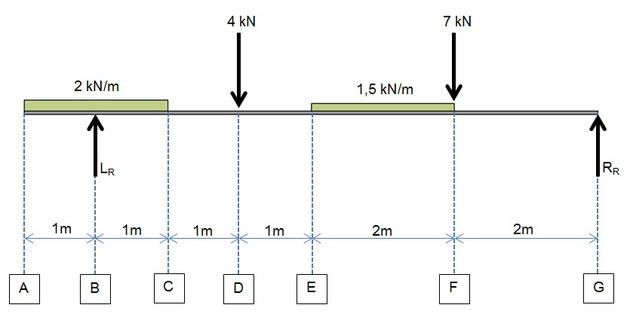

## FIGURE 4

4.1 Calculate the reaction at the supports. (5)

4.2 Draw a shear-force diagram. (6)

4.3 Calculate the position of all the turning points. (4)

4.4 Calculate the bending moment at all the relevant points. (5)

4.5 Draw a bending moment diagram. (5)

4.6 Calculate the point of inflection (or point of contraflexure) on the beam. (5)

##### [30]

-6- T1650**(E)**(A13)T

**QUESTION 5**

FIGURE 5 has the following features:

* Frame structure supported between a fixed and a roller support
* Members AG = BI = CJ = DL
* Members GE = HE = KE = LE = 2 m

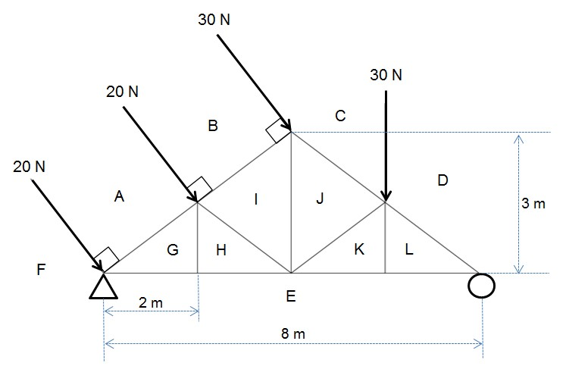

##### FIGURE 5

5.1 Calculate the reaction at the roller support. (1)

5.2 Calculate the reaction at the fixed support. (3)

5.3 Graphically determine the magnitude of force and the nature of the force in

members EG, HI, IJ, KL, DL, JC and BI. (21)

**[25]**

**TOTAL:**  **100**

-1- T1650**(E)**(A13)T

##### STRENGTH OF MATERIALS AND STRUCTURES N5

Any applicable equation or formula may be used.

*F*



*A*

*X*



*L*

*FL*

*E* 

*Ax*

 1 1 

*F* *A*1*E*  *A*2*E**t*(2 1)



*F* *AL*11*E*  *AL*22*E* *L*11*t*  *L*22*t*



1

*U*   *Fx*

2

2

*AE*

*L*

*F*

2

*ac*

*b*

*b*

4

2

−



−

*U* 

*x* 

2*a*

*F*2*L mg*(*h* ) 

2*AE*

*T*  *G*  

*J r L*

(*D*4  *d*4)

*J* 

32

❐ (*D*4  *d*4)

*T*  

16 *D*

*T*  *D*3

16

10,2 *TL*

 4

*GD*

10,2 *TL*

 *G*(*D*4  *d*4) *P*  2*NT*

*WL*

*M* 

8

*L*2

*M* 

8

*WL*

*M* 

4

*I*

*Z*  *y*

*M* *Z*

*I*   (*D*4  *d*4)

64

*I*   *D*4

64

*bd*3

*Ixx* 

12

2*EI*

❐ *F*  2

###### Le

*F*  *A* 2

1  *a* *Le* 

 *k* 

42*EI*

*F*  2

*L*

*F* 

2

4

1















*k*

*L*

*a*

*A*

⬧

*A*

*I*

*k* 

*S* .*v* *Le* ; *S* . *R* *Le* *k k*

Hinged ends *Le*  *L*

*L*

Fixed ends *Le* 

2

Copyright reserved Please turn over -2- T1650**(E)**(A13)T

*M*  *E L*

  One end fixed, one end hinged *Le* 

*I Y R* 2

One end fixed, one end free *Le*  2*L*

*PD*



2.*t*

*PD*



4 *t*

(*p*  *d*) *t**t* 100

 

*pt**t*

*d*2 *n*

100

4

*pt**t ndt**c* 100



*pt**t*

*d*2

*t*(*p*  *d*) *t*   *nt*

4

(*p*  *d*) *t**t*  *dtn**c*

Copyright reserved